

**American International University- Bangladesh**

**Department of Computer Science**

**Assignment Cover Sheet**

|  |  |  |  |
| --- | --- | --- | --- |
| **Course Name** | Data Communication | | |
| **Assignment On** | Laboratory Task | **No.** | 5 |
| **Lecturer Name** | Md. Navid Bin Anwar | | |
| **Semester** | Summer 2019-20 | | |
| **Submission Date** | 26.8.20 | | |
| **Section** | F | | |
| **Group No.** | 6 | | |
|  |  |  | |
| **Student Name** | **Student ID** | **Contribution (out of 100%)** | |
|  | 18-37645-1 | 20% | |
|  | 18-37598-1 | 20% | |
|  | 18-37855-2 | 20% | |
|  | 18-37459-1 | 20% | |
|  | 18-37609-1 | 20% | |
| **Teacher Remarks**  (Only for teacher) |  | | |

Performance Task for Lab Report: (your ID = AB-CDEFG-H)

(a) Convert DEF into binary bits (Decimal to Binary).

(b) Show the modulated analog signal considering BASK, BFSK, BPSK, and QPSK

**Answer:**

1. My id is 18-37645-1

DEF=764

764 / 2 = 382 with 0 remainder  
382 / 2 = 191 with 0 remainder  
191 / 2 = 95 with 1 remainder  
95 / 2 = 47 with 1 remainder  
47 / 2 = 23 with 1 remainder  
23 / 2 = 11 with 1 remainder  
11 / 2 = 5 with 1 remainder  
5 / 2 = 2 with 1 remainder  
2 / 2 = 1 with 0 remainder  
1 / 2 = 0 with 1 remainder

76410 = 10111111002

Binary format is: 1011111100

(b)

Amplitude Shift Keying(BASK):

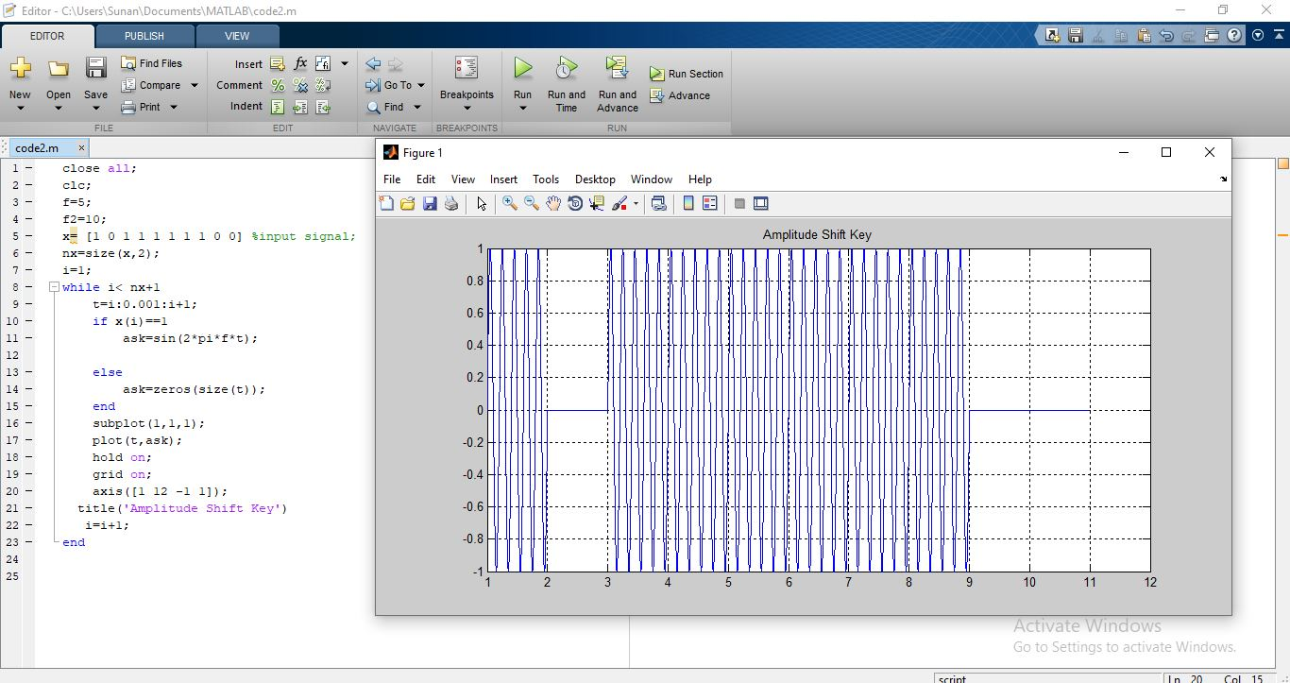

Frequency Shift Keying(BFSK)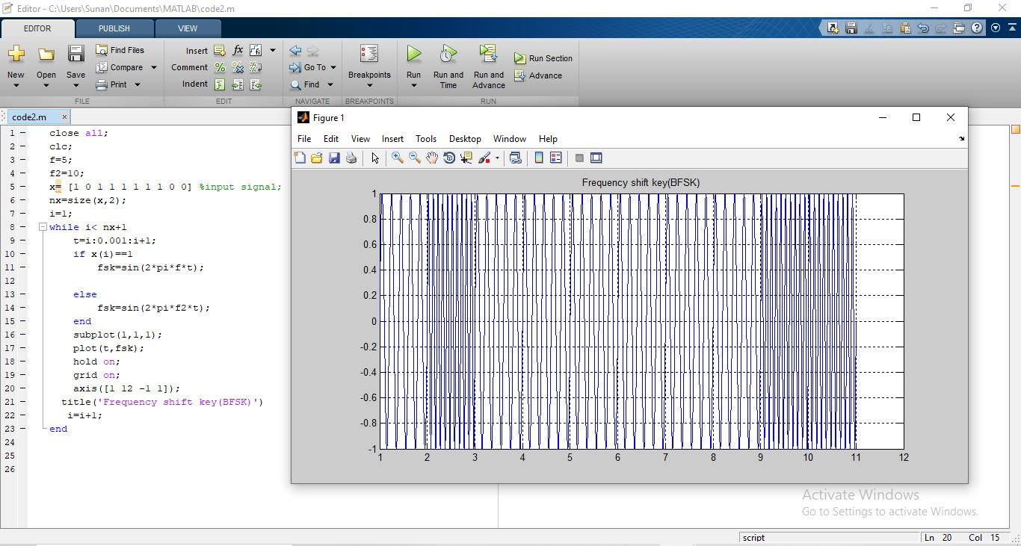

Phase Shift Keying(BPSK):

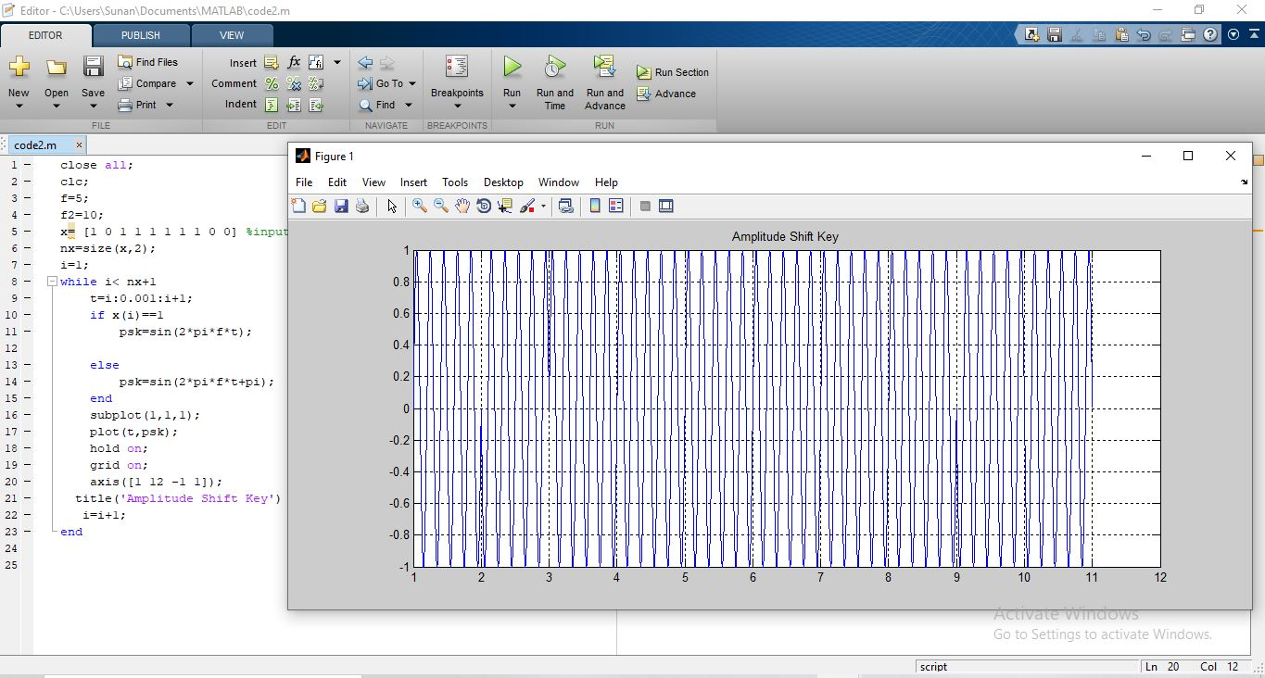

PSK1:

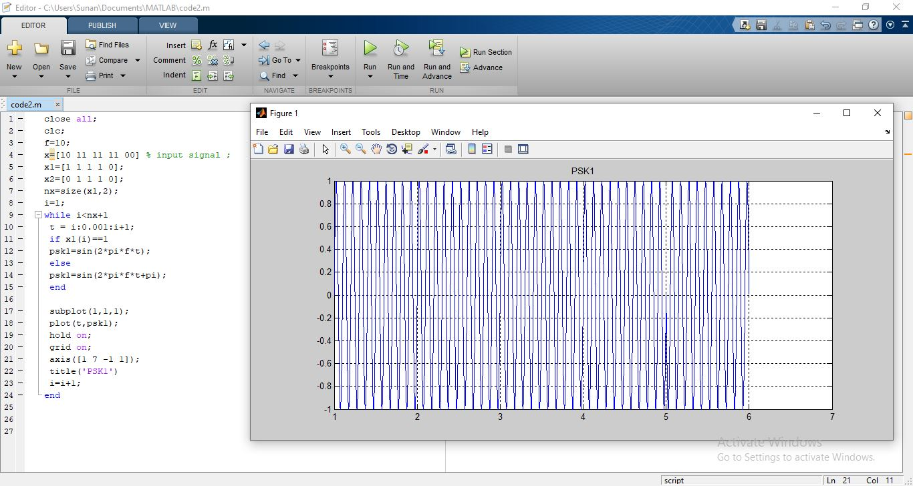

PSK2:

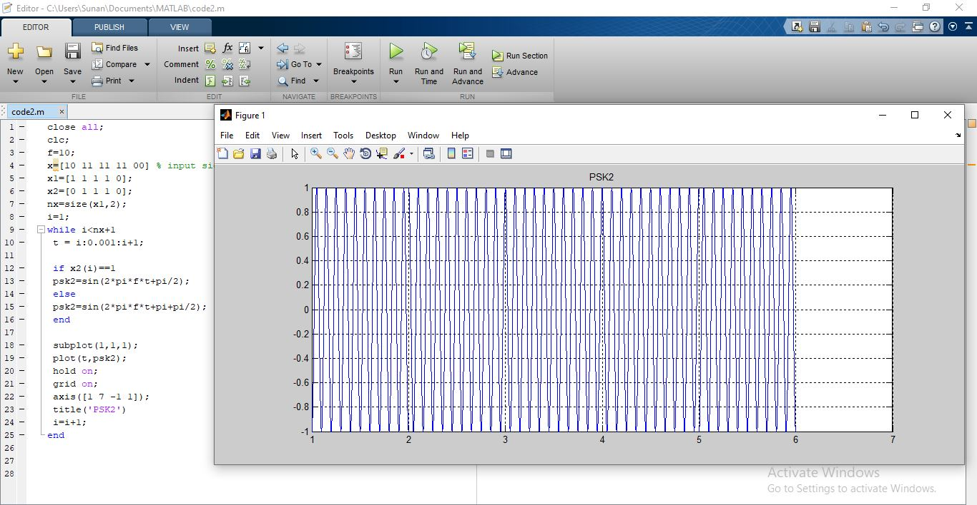

GPSK:

